**User Manual :Multiple Office Mapping**

**Table of Contents**

1 Introduction 3

1.1 Purpose 3

2 Access of FMDSS Application 3

3 Multiple Office Mapping 4

3.1.1 Getting Started with Multiple Office Mapping 4

3.1.2 Getting Start with Remove Dual Office Mapping 9

4. Do’s and Don’ts 14

4.1 DO ’s 14

4.2 Don ’ts 14

5.HelpDesk.....................................................................................................................................................15

# Introduction

# 1.1 Purpose

This Help Document guides and helps the department user to Map Multiple Office and complete the respective requirements.

# Access of FMDSS Application

* 1. User will type URL address of FMDSS application [(http://fmdss.forest.rajasthan.gov.in/)](http://fmdss.forest.rajasthan.gov.in/) in address bar of web browser.
  2. Then click on “SSO” login.
  3. Enter "SSO ID", "Password" and 6 digit captcha code and click on login to access FMDSS application

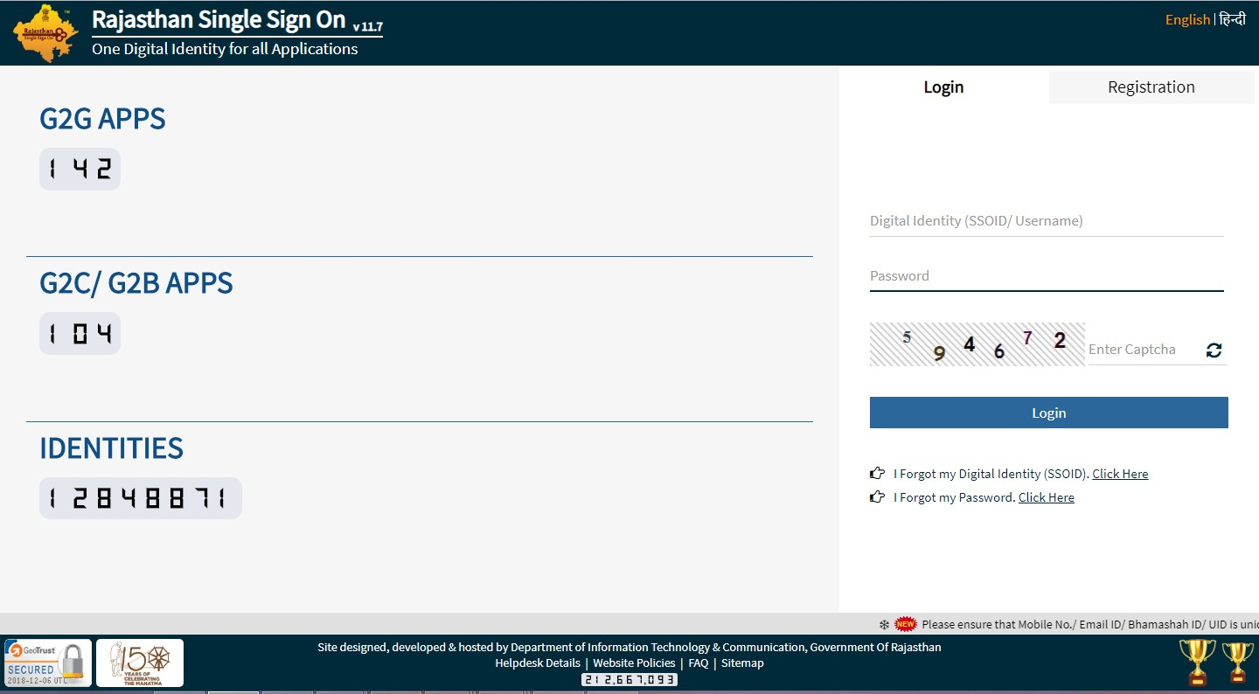

* 1. If any user does not have "SSO ID", then he/she may create his/her "SSO ID" through “New Users Registration”.

# Multiple Office Mapping

***User Management->Multiple Office Mapping->SSO ID Details***

# 3.1.1 Getting Started with Multiple Office Mapping

1.Click on “User Management ” left side of dashboard.

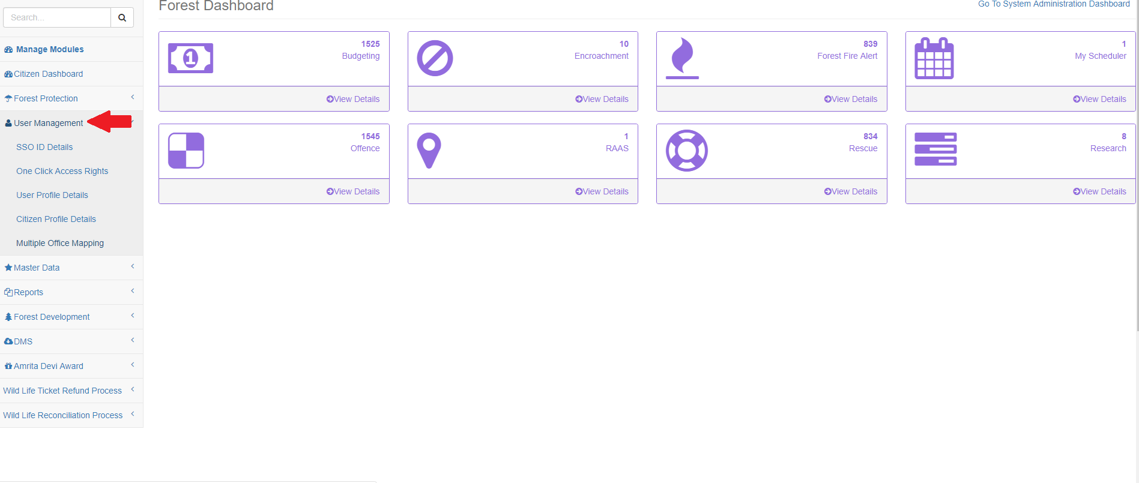

2.After Clicking on User Management,Click on “Multiple Office Mapping”.

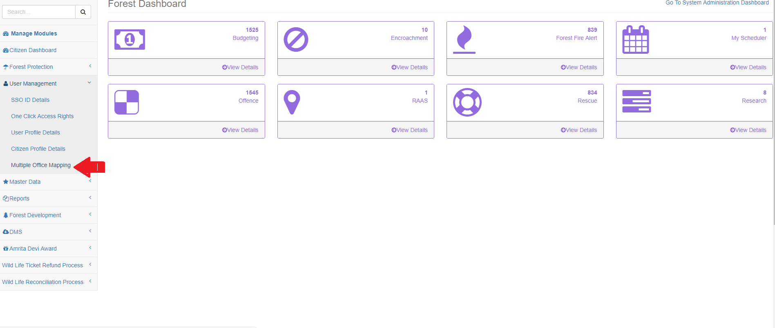

3.After Clicking on “Multiple Office Mapping”.,”SSO ID Details” form will open.

(Note: Entered SSO ID should be valid, do not add space in between the characters)

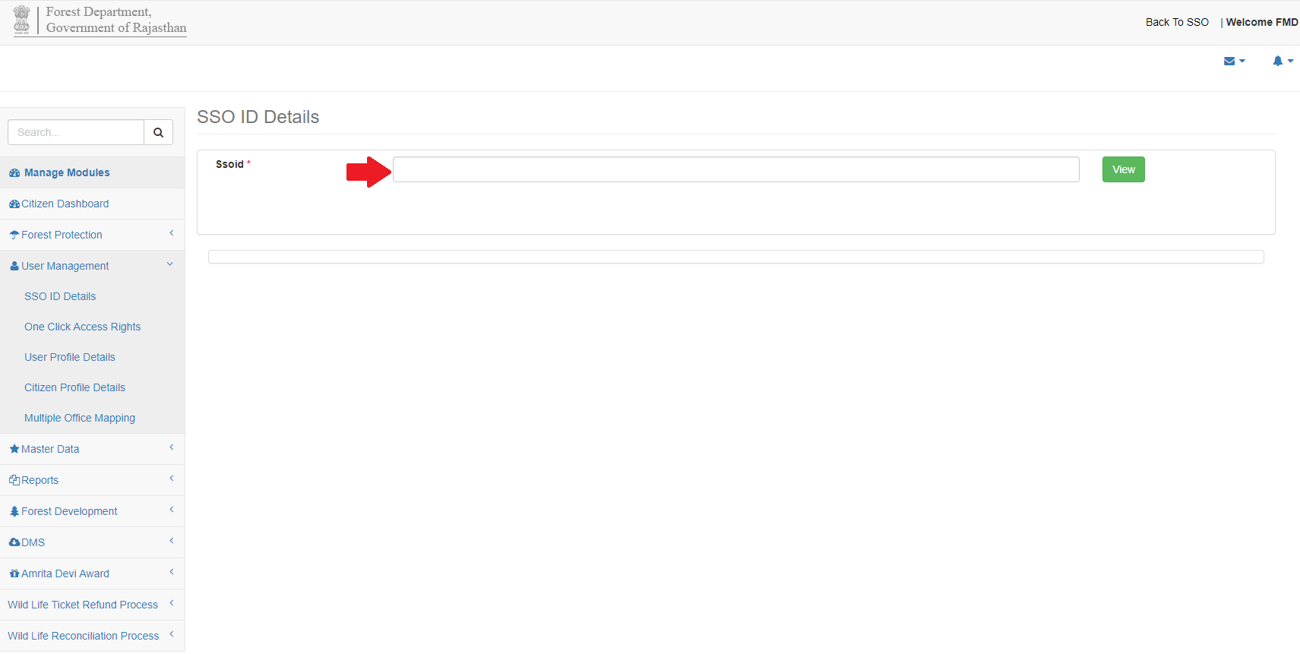

4.Enter valid “SSO ID” of department user in SSO ID text box.

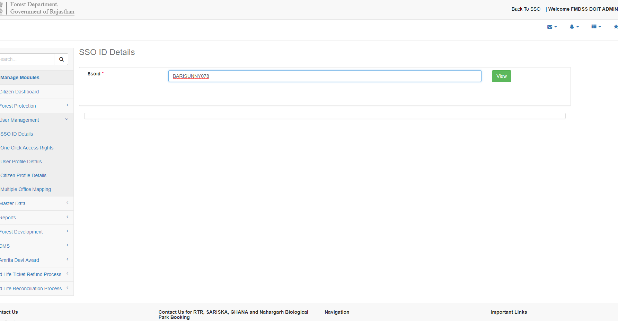

5.After entering valid “SSO ID” of department user,Click on “View” button.

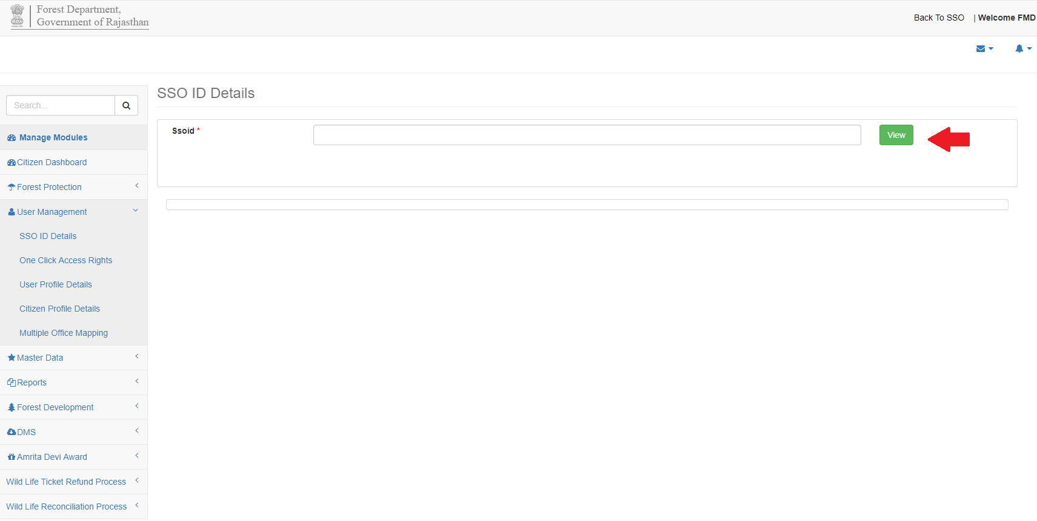

(Note: Do Not Entered SSO ID of citizen ,Multiple office mapping is only for departmet user)

6.After Clicking on “View Button”,User Details grid will open .

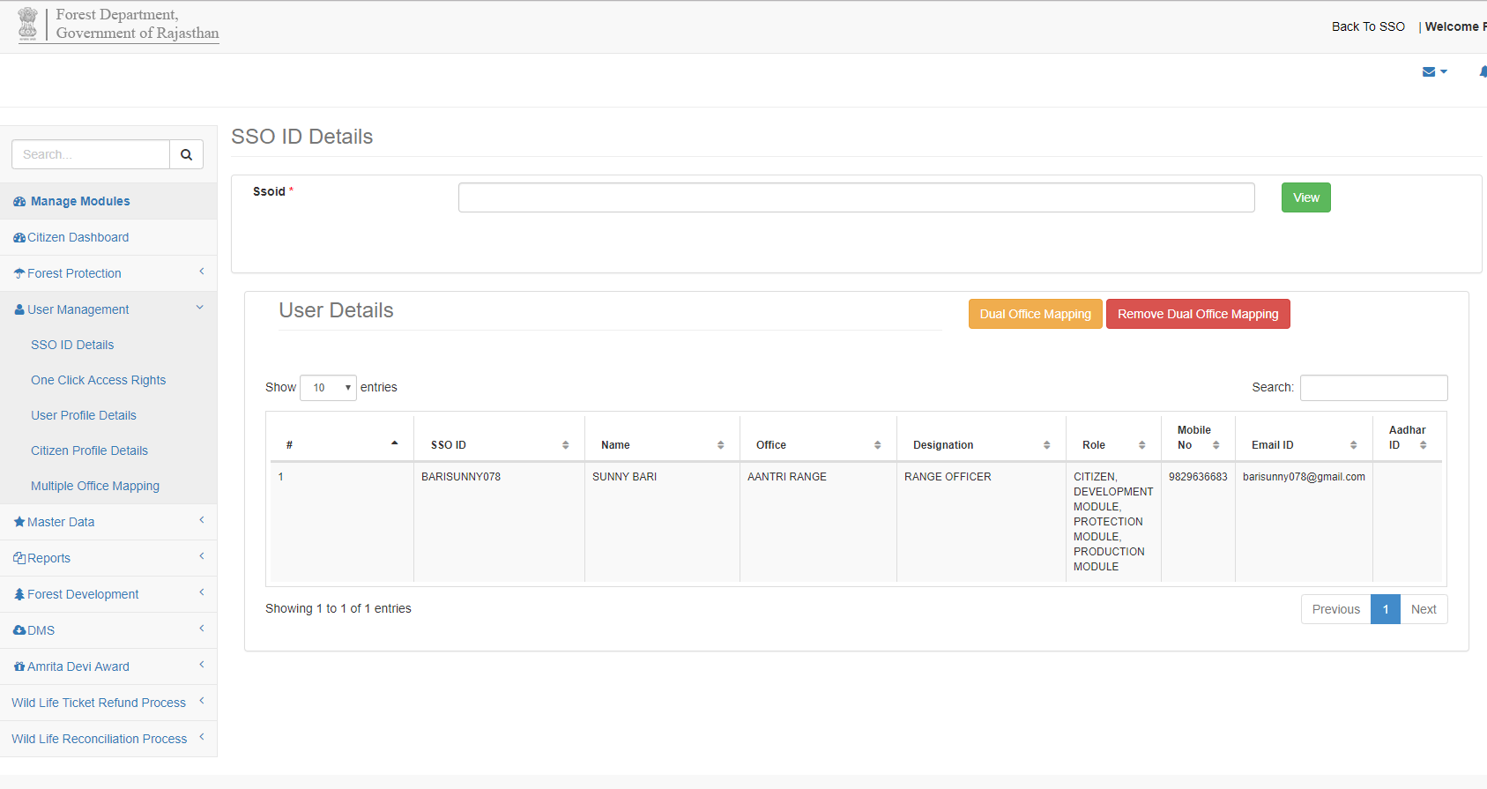

7.In User Details grid ,Department user can view entered “SSO ID” roles mapped ,Designation,Name,Office,Role,Mobile No,Email Id and other information.

8.In User Details grid ,Department user can map multiple officer by clicking on “Dual Office Mapping” button.

9.After clicking on “Dual Office Mapping” button.“Mapping with Multiple Office ”form will open .

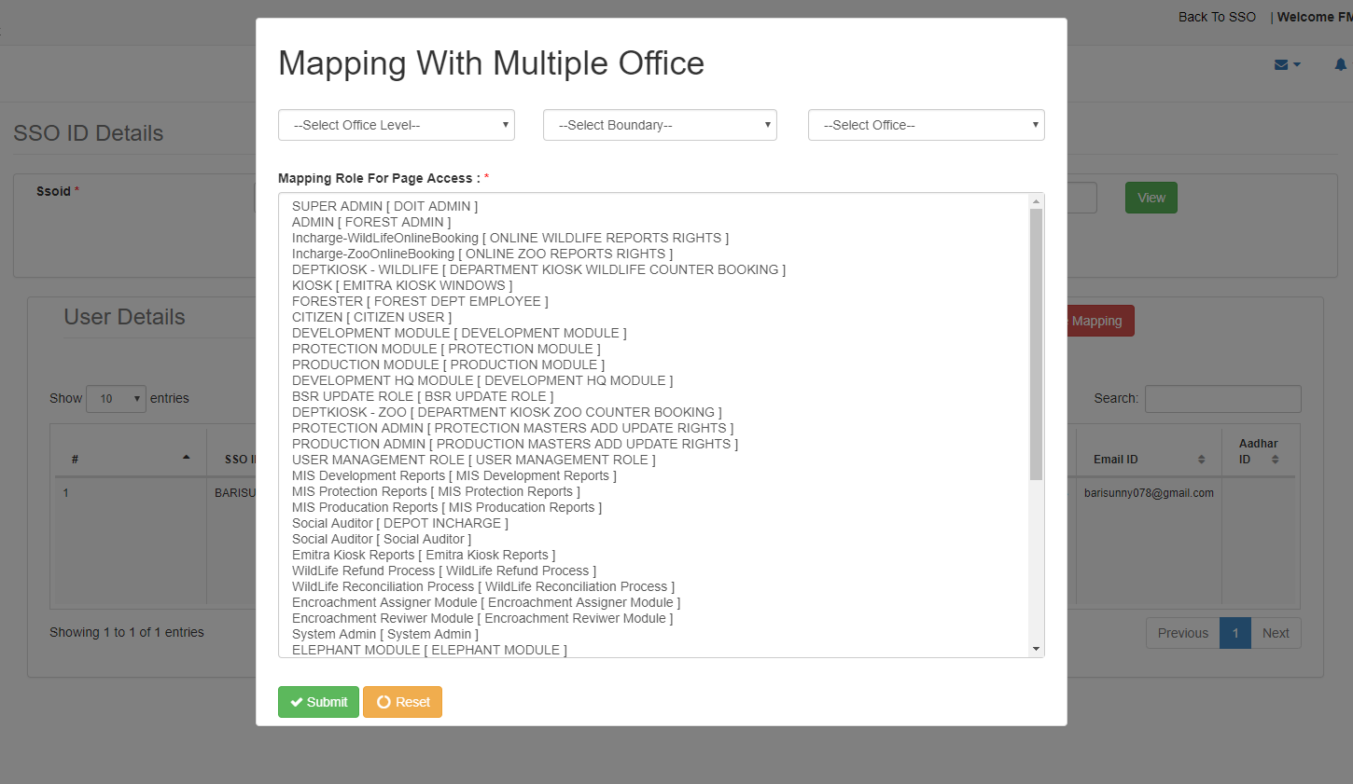

10.In Mapping with Multiple Office ”form,Select “Office Level” from drop down menu .

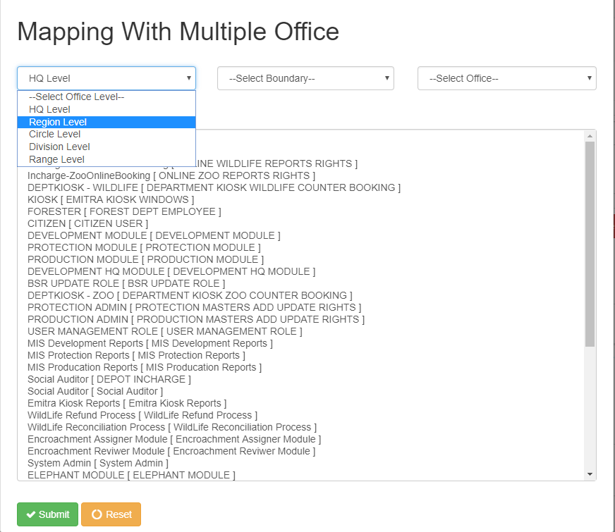

11.In Mapping with Multiple Office ”form,Select “Boundary” from drop down menu on the basis of selected “Office Level” .



12.In Mapping with Multiple Office ”form,Select “Office” from drop down menu ,On the basis of selected “Boundary” ,“Office Level”.

13.After Selecting “Office ” from the drop down menu.Select “Mapping Roles” from Mapping Roles for Page Access grid.

(Note:Department user can map multiple office at a time )



14. After successfully Selecting “Mapping Role For Page Access”,Click on “Submit”

button .

15.If department user wants to “Reset”,Click on “Reset” button.

16. After Successfully clicking on “Submit” button,User will re-direct to “SSO ID Details” page and message will displayed “Multiple Office has been mapped for SSO ID : …………..”

17.User can check mapped Role’s which user had mapped by entering “SSO ID” in SSO ID text box and Clicking on view button .

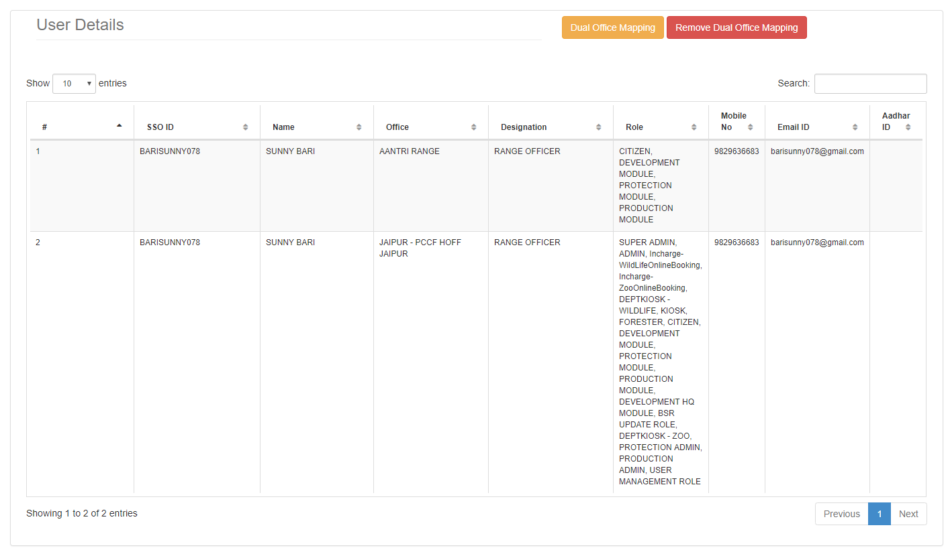

# 3.1.2 Getting Start with Remove Dual Office Mapping

1.Click on “User Management ” left side of dashboard.



2.After Clicking on User Management,Click on “Multiple Office Mapping”.



3.After Clicking on “Multiple Office Mapping”.,”SSO ID Details” form will open.

(Note: Entered SSO ID should be valid, do not add space in between the characters)



4.Enter valid “SSO ID” of department user in SSO ID text box.



5.After entering valid “SSO ID” of department user,Click on “View” button.



(Note: Do Not Entered SSO ID Of citizen ,Multiple office mapping is only for departmet user)

6.After Clicking on “View Button”,User Details grid will open .



7.In User Details grid ,Department user can view entered “SSO ID” roles mapped ,Designation,Name,Office,Role,Mobile No,Email Id and other information.

8.In “User Details” grid,Click on “Remove Dual office Mapping”.

9.After Clicking on “Remove Dual Office Mapping”,Alert Will display “Multiple office has been unmapped”,Click on “Ok” button

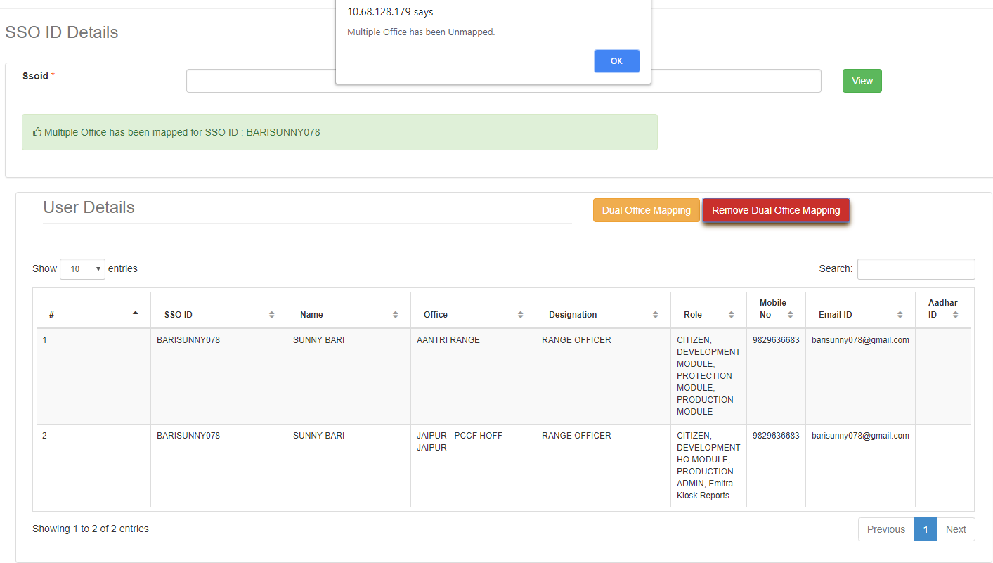

10.After Clicking on “OK” button,Message will display “ Multiple Office Mapping has been deleted.”

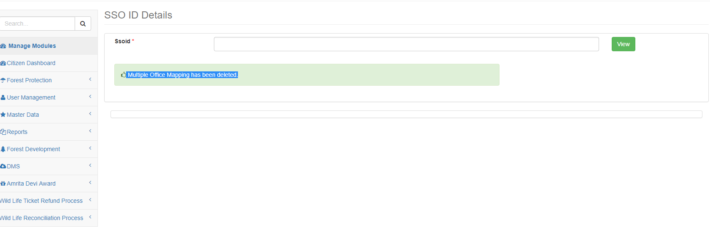

## 4. Do’s and Don’t

For filling the entire form kindly follow the given Do’s and Don’ts of Multiple Mapping:

## 4.1 DO ’s

1. User must login to FMDSS with valid username and password which is registered through SSO.

1. Avoid multiple login using same username and password and booking for other.
2. While entering ID do not put space extra character, which may lead to ghost entry.
3. While Mapping please enter all mandatory fields.
4. Please logout after every usage of Multiple office mapping.

## 4.2 Don ’ts

1.Do not Enter Citizen “SSO ID”,Multiple role mapping is only for forest department users.

2.The registrations with in valid address, email-IDs and mobile numbers are liable to is

deactivated.

3.Do not click on back button and refresh while mapping multiple office role.

# 5.Helpdesk

Any user can get help from help desk of FMDSS on any issues pertaining in utilization of FMDSS application.

User may contact the help desk team through email . The contact details of the help desk team are:

Email Id: [helpdesk.fmdss@rajasthan.gov.in](mailto:helpdesk.fmdss@rajasthan.gov.in)